EXECUTIVE SUMMARY

RESETTLEMENT ACTION PLAN

For

Rongsai–Boijhora–Bajengdoba (RBB) Road-ko single lane pora
intermediate
lane bilsi upgradation ka·se, Meghalaya Logistics and Connectivity
Improvement Project (MLCIP) rang·san, World Bank fund ka·se.

Submitted To

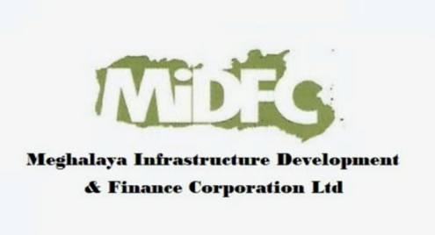

Meghalaya Infrastructure Development Finance Corporation (MIDFC) Ltd.
House No. L/A-56, Lower Nongrim Hills, Top Floor,
Meghalaya Basin Development Authority (MBDA) Building,
Shillong East Khasi Hills, Meghalaya-793003

EXECUTIVE SUMMARY

1. Project Background
- ongsai–Borjhora–Bajengdoba (RBB) Road (Corridor–3) ka project ong·a 18.27 km bilsi, Kosi Junction pora Bajengdoba bilsi, North Garo Hills District, Meghalaya-odong·a.
- Iani project Meghalaya Logistics and Connectivity Improvement Project (MLCIP) ni bak ong·a, World Bank (USD 240 million) aro Government of Meghalaya (USD 60 million) fund ka·se.

- Project ni objective-rang ong·a: connectivity improve ka·na, logistics infrastructure strengthen ka·na, market access enhance ka·na, agriculture aro horticulture produce ni transportation cost kom ka·na, aro climate-resilient road-rang-ni institutional capacity build ka·na.
2. Need for the Resettlement Action Plan
• Road widening aro construction kam-rang (3.75 m single lane pora 5.5 m intermediate lane) ni somoian social impact-rang handle ka·na RAP prepare ka·se.
• Indigenous (tribal) community-rang-ni land aro property rights protect ka·na RAP-ni main aim ong·a.
• Project Affected Households (PAHs) rang-na compensation, resettlement aro rehabilitation measures MPWD Entitlement Matrix anusar provide ka·na ong·a.
• FPIC (Free, Prior and Informed Consent) planning-o integrate ka·a, jate community rights respect ka·na man·a.
3. Project Impacts and Affected Population
• Total PAHs: 150 household
• Total PAPs: 262 Project Affected Persons
• Community composition ong·a: Garo (78%), Rabha (11%), Muslim (9%), aro Others (2%).
• Minor private aro government land acquisition dong·a; curve improvement aro drainage ni gimin tree cutting chhonbat dong·a.
• Vulnerable household-rang:
– 28 women-headed household (19%)
– 14 elderly persons (9%)
– Sab vulnerable household-rang Scheduled Tribe ong·a.

4. Socio-Economic Profile
• Gender distribution balanced ong·a: 52% male, 48% female.
• Livelihood-rang mainly agriculture aro allied activities-o depend ka·a; kichu household-rang small-scale business-o dong·a.
• Literacy level moderate ong·a; basic community service-rang-ni access limited ong·a.
• Socio-cultural context-o matrilineal Garo society, strong local governance (Nokma, village council) aro traditional land management system dong·a.

5. Consultation, Disclosure, and FPIC
Project preparation process-o meaningful consultation-rang conduct ka·se, World Bank ESS7 aro ESS10 anusar. September pora December 2025 bilsi FPIC ni 4 round consultation ka·se.
• Three FPIC meeting Bajengdoba Multi-Facility Hall-o conduct ka·se:
– 09.09.2025
– 19.09.2025
– 25.09.2025
• Stakeholder-rang ong·a: PAHs, Nokmas, government official-rang, civil society, youth aro women group-rang.
• Key outcome-rang ong·a: community consent, retaining wall-rang, proper drainage, safety measure-rang, separate toilet-rang aro streetlight-rang-ni inclusion.
• Women FGDs-o economic participation aro skill development ni demand-rang highlight ka·se.

6. Eligibility and Entitlements
Sab affected person-rang, non-titleholder-rang (squatters, encroachers) sahita, MPWD Entitlement Matrix anusar assistance pa·na eligible ong·a, jekon World Bank ESF-o align ka·a.
Main entitlement-rang ong·a:
• Affected structure-rang-na full replacement cost-o compensation (depreciation bina)
• Resettlement aro transitional assistance (applicable ong·ode)
• Vulnerable household-rang-na additional assistance
• Livelihood restoration support, skill development aro income restoration sahita

7. Institutional Arrangements and Grievance Redress
Meghalaya Public Works Department (PWD) RAP implementation ni main responsibility la·a, E&S Cell, district administration aro GHADC sahita support ka·a.
Two-tier Grievance Redress Mechanism (GRM) establish ka·se, jate complaint-rang transparent aro time-bound tarike-o resolve ka·na man·a. GRM village, district aro state level-o accessible ong·a.

8. Implementation Schedule and Budget
RAP implementation phased manner-o civil works sahita synchronize ka·a.
Sab compensation aro assistance construction start ong·na skang affected section-rang-o pay ka·na ong·a.
Resettlement and Rehabilitation (R&R) budget estimate ka·se, jano include ka·a: structure compensation, resettlement assistance, livelihood restoration, administrative cost, monitoring aro contingency.

9. Monitoring and Evaluation
Internal aro external monitoring system employ ka·na ong·a, jate RAP implementation effective ong·a.
Monitoring indicator-rang ong·a: physical progress, financial disbursement, grievance redress aro livelihood restoration outcome-rang.
Impact evaluation-o assess ka·a jate affected household-rang nijor living standard restore ba improve ka·na man·e.

10. Grievance Redress Mechanism
Ka following flowchart-o two-tier grievance redressal mechanism ni structure, responsibility aro resolution timeline-rang show ka·a.
Tier I: Project Site Level | Responsibility: VECs & Headman  Timeline: Resolution within 15 days  If unresolved → Escalate to PMU (Tier II)
Tier II: State Level (PMU) | Responsibility: Secretary Planning, Chief Engineer,  Project Director, Social Expert  Timeline: Resolution within 15 days

Grievance Redressal Mechanism
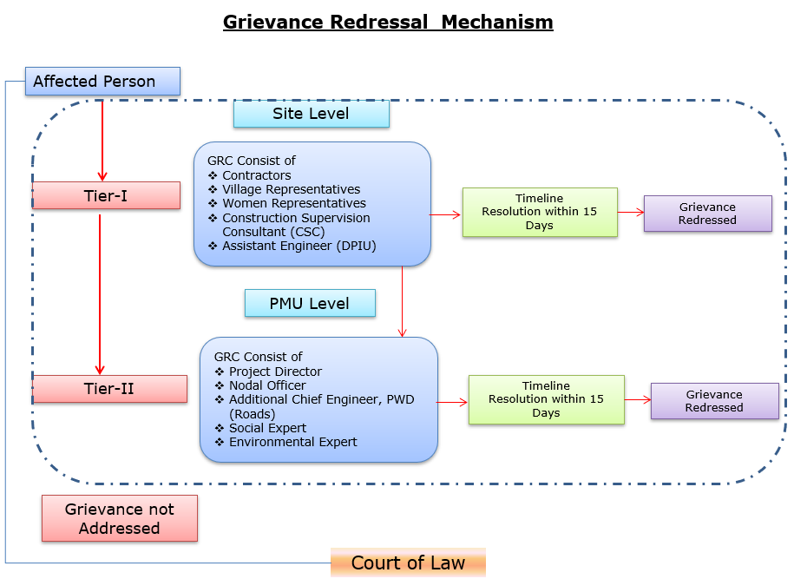

Details of contact for Grievances
Description | Contact details
Company: | PWD, Meghalaya
To: | Chief Engineer-cum-Nodal officer
Address: | HV9P+GFJ, Lachumiere, Shillong, Meghalaya 793001
E-mail: | esmlcip@gmail.com
Website: | http://megpwd.gov.in/contacts.html
Telephone: | Tel: 0364-3572466
Fax: | -

11. Conclusion
Rongsai–Boijhora–Bajengdoba (RBB) Road ni Resettlement Action Plan (RAP) project-ni inclusive development, tribal rights-ni protection, aro social sustainability-ni strong commitment-ko dak mesok ka·a. Project-o resettlement impact chhonbat ong·a, community engagement bata ong·e strong ong·a, aro mitigation measures strong aro effective ong·a. Iani sab rang·san project-o significant socio-economic benefit-rang deliver ka·na man·a aro affected person-rang-ko fair aro equitable tarike-o treat ka·na ong·a.

